

Diseño de sistemas digitales.

Practica 9: Mensaje con display de 16 segmentos (24-32 Caracteres).

Adrian Emilio Vazquez Icedo

Gilberto Espinoza Maciel

9 de octubre de 2017

Hermosillo, Sonora

**Tabla de verdad**

|  |  |  |  |  |  |  |  |  |  |  |  |  |  |  |  |  |  |  |  |  |  |  |
| --- | --- | --- | --- | --- | --- | --- | --- | --- | --- | --- | --- | --- | --- | --- | --- | --- | --- | --- | --- | --- | --- | --- |
| A | B | C | D | E |  |  | 1 | 2 | 3 | 4 | 5 | 6 | 7 | 8 | 9 | 10 | 11 | 12 | 13 | 14 | 15 | 16 |
| 0 | 0 | 0 | 0 | 0 | H |  | 0 | 0 | 0 | 0 | 1 | 1 | 0 | 0 | 0 | 0 | 0 | 1 | 1 | 1 | 1 | 0 |
| 0 | 0 | 0 | 0 | 1 | A |  | 1 | 1 | 0 | 0 | 1 | 1 | 0 | 0 | 0 | 0 | 0 | 1 | 1 | 1 | 1 | 0 |
| 0 | 0 | 0 | 1 | 0 | C |  | 1 | 1 | 0 | 0 | 1 | 1 | 0 | 1 | 1 | 0 | 0 | 0 | 0 | 0 | 0 | 0 |
| 0 | 0 | 0 | 1 | 1 | K |  | 0 | 0 | 0 | 0 | 1 | 1 | 0 | 0 | 0 | 0 | 1 | 0 | 0 | 1 | 0 | 1 |
| 0 | 0 | 1 | 0 | 0 | I |  | 0 | 0 | 0 | 0 | 0 | 0 | 0 | 0 | 0 | 0 | 0 | 1 | 0 | 0 | 1 | 0 |
| 0 | 0 | 1 | 0 | 1 | N |  | 0 | 0 | 0 | 1 | 1 | 1 | 0 | 0 | 0 | 0 | 1 | 1 | 0 | 0 | 1 | 0 |
| 0 | 0 | 1 | 1 | 0 | G |  | 1 | 1 | 0 | 0 | 1 | 1 | 0 | 1 | 1 | 0 | 0 | 1 | 1 | 0 | 0 | 0 |
| 0 | 0 | 1 | 1 | 1 |  |  | 0 | 0 | 0 | 0 | 0 | 0 | 0 | 0 | 0 | 0 | 0 | 0 | 0 | 0 | 0 | 0 |
| 0 | 1 | 0 | 0 | 0 | F |  | 1 | 1 | 0 | 0 | 1 | 1 | 0 | 0 | 0 | 0 | 0 | 0 | 1 | 1 | 0 | 0 |
| 0 | 1 | 0 | 0 | 1 | O |  | 1 | 1 | 0 | 0 | 1 | 1 | 0 | 1 | 1 | 0 | 0 | 1 | 0 | 0 | 1 | 0 |
| 0 | 1 | 0 | 1 | 0 | R |  | 1 | 1 | 0 | 0 | 1 | 1 | 0 | 0 | 0 | 0 | 1 | 0 | 1 | 1 | 1 | 0 |
| 0 | 1 | 0 | 1 | 1 |  |  | 0 | 0 | 0 | 0 | 0 | 0 | 0 | 0 | 0 | 0 | 0 | 0 | 0 | 0 | 0 | 0 |
| 0 | 1 | 1 | 0 | 0 | L |  | 0 | 0 | 0 | 0 | 1 | 1 | 0 | 1 | 1 | 0 | 0 | 0 | 0 | 0 | 0 | 0 |
| 0 | 1 | 1 | 0 | 1 | I |  | 0 | 0 | 0 | 0 | 0 | 0 | 0 | 0 | 0 | 0 | 0 | 1 | 0 | 0 | 1 | 0 |
| 0 | 1 | 1 | 1 | 0 | F |  | 1 | 1 | 0 | 0 | 1 | 1 | 0 | 0 | 0 | 0 | 0 | 0 | 1 | 1 | 0 | 0 |
| 0 | 1 | 1 | 1 | 1 | E |  | 1 | 1 | 0 | 0 | 1 | 1 | 0 | 1 | 1 | 0 | 0 | 0 | 1 | 1 | 0 | 0 |
| 1 | 0 | 0 | 0 | 0 |  |  | 0 | 0 | 0 | 0 | 0 | 0 | 0 | 0 | 0 | 0 | 0 | 0 | 0 | 0 | 0 | 0 |
| 1 | 0 | 0 | 0 | 1 | L |  | 0 | 0 | 0 | 0 | 1 | 1 | 0 | 1 | 1 | 0 | 0 | 0 | 0 | 0 | 0 | 0 |
| 1 | 0 | 0 | 1 | 0 | I |  | 0 | 0 | 0 | 0 | 0 | 0 | 0 | 0 | 0 | 0 | 0 | 1 | 0 | 0 | 1 | 0 |
| 1 | 0 | 0 | 1 | 1 | V |  | 0 | 0 | 0 | 0 | 1 | 1 | 1 | 0 | 0 | 0 | 0 | 0 | 0 | 0 | 0 | 1 |
| 1 | 0 | 1 | 0 | 0 | I |  | 0 | 0 | 0 | 0 | 0 | 0 | 0 | 0 | 0 | 0 | 0 | 1 | 0 | 0 | 1 | 0 |
| 1 | 0 | 1 | 0 | 1 | N |  | 0 | 0 | 0 | 1 | 1 | 1 | 0 | 0 | 0 | 0 | 1 | 1 | 0 | 0 | 1 | 0 |
| 1 | 0 | 1 | 1 | 0 | G |  | 1 | 1 | 0 | 0 | 1 | 1 | 0 | 1 | 1 | 0 | 0 | 1 | 1 | 0 | 0 | 0 |
| 1 | 0 | 1 | 1 | 1 |  |  | 0 | 0 | 0 | 0 | 0 | 0 | 0 | 0 | 0 | 0 | 0 | 0 | 0 | 0 | 0 | 0 |
| 1 | 1 | 0 | 0 | 0 | F |  | 1 | 1 | 0 | 0 | 1 | 1 | 0 | 0 | 0 | 0 | 0 | 0 | 1 | 1 | 0 | 0 |
| 1 | 1 | 0 | 0 | 1 | O |  | 1 | 1 | 0 | 0 | 1 | 1 | 0 | 1 | 1 | 0 | 0 | 1 | 0 | 0 | 1 | 0 |
| 1 | 1 | 0 | 1 | 0 | R |  | 1 | 1 | 0 | 0 | 1 | 1 | 0 | 0 | 0 | 0 | 1 | 0 | 1 | 1 | 1 | 0 |
| 1 | 1 | 0 | 1 | 1 |  |  | 0 | 0 | 0 | 0 | 0 | 0 | 0 | 0 | 0 | 0 | 0 | 0 | 0 | 0 | 0 | 0 |
| 1 | 1 | 1 | 0 | 0 | H |  | 0 | 0 | 0 | 0 | 1 | 1 | 0 | 0 | 0 | 0 | 0 | 1 | 1 | 1 | 1 | 0 |
| 1 | 1 | 1 | 0 | 1 | A |  | 1 | 1 | 0 | 0 | 1 | 1 | 0 | 0 | 0 | 0 | 0 | 1 | 1 | 1 | 1 | 0 |
| 1 | 1 | 1 | 1 | 0 | C |  | 1 | 1 | 0 | 0 | 1 | 1 | 0 | 1 | 1 | 0 | 0 | 0 | 0 | 0 | 0 | 0 |
| 1 | 1 | 1 | 1 | 1 | K |  | 0 | 0 | 0 | 0 | 1 | 1 | 0 | 0 | 0 | 0 | 1 | 0 | 0 | 1 | 0 | 1 |
|  |  |  |  |  |  |  |  |  |  |  |  |  |  |  |  |  |  |  |  |  |  |  |
|  |  |  |  |  |  |  | 14 | 14 | 0 | 2 | 23 | 23 | 1 | 9 | 9 | 0 | 6 | 14 | 12 | 12 | 14 | 3 |

1. A’B’C’D’E v A’B’C’DE’ v A’B’CDE’ v A’BC’D’E’ v A’BC’D’E v A’BC’DE’ v A’BCDE’ v A’BCDE v AB’CDE’ v ABC’D’E’ v ABC’D’E v ABC’DE’ v ABCD’E v ABCDE’

A’C’D’E v A’B’DE’ v A’BC’E’ v A’BCD v ACDE’ v ABC’D’ v ABC’DE’ v ABCD’E

A’(C’D’E v B’DE’ v BC’E’ v BCD) v A(CDE’ v BC’D’ v BC’DE’ v BCD’E)

1. A’B’C’D’E v A’B’C’DE’ v A’B’CDE’ v A’BC’D’E’ v A’BC’D’E v A’BC’DE’ v A’BCDE’ v A’BCDE v AB’CDE’ v ABC’D’E’ v ABC’D’E v ABC’DE’ v ABCD’E v ABCDE’

A’C’D’E v A’B’DE’ v A’BC’E’ v A’BCD v ACDE’ v ABC’D’ v ABC’DE’ v ABCD’E

A’(C’D’E v B’DE’ v BC’E’ v BCD) v A(CDE’ v BC’D’ v BC’DE’ v BCD’E)

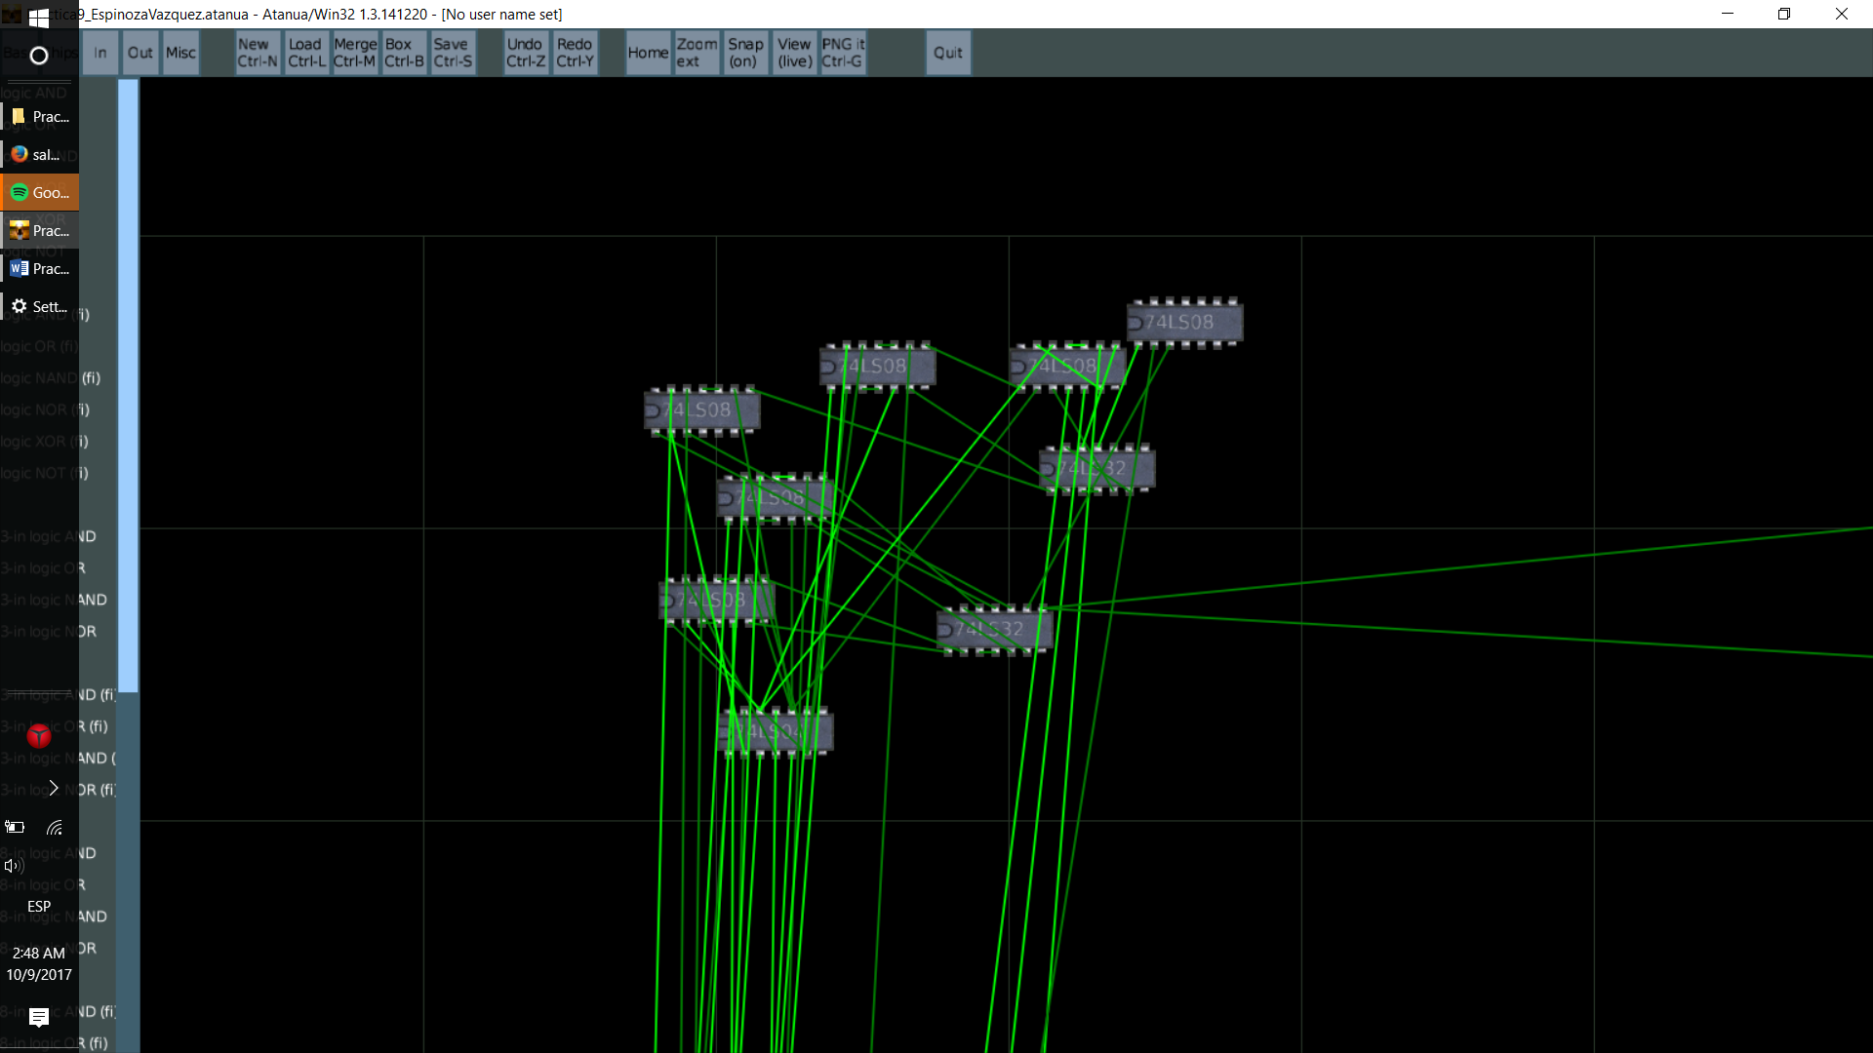

1. _
2. A’B’CD’E v AB’CD’E

B’CD’E

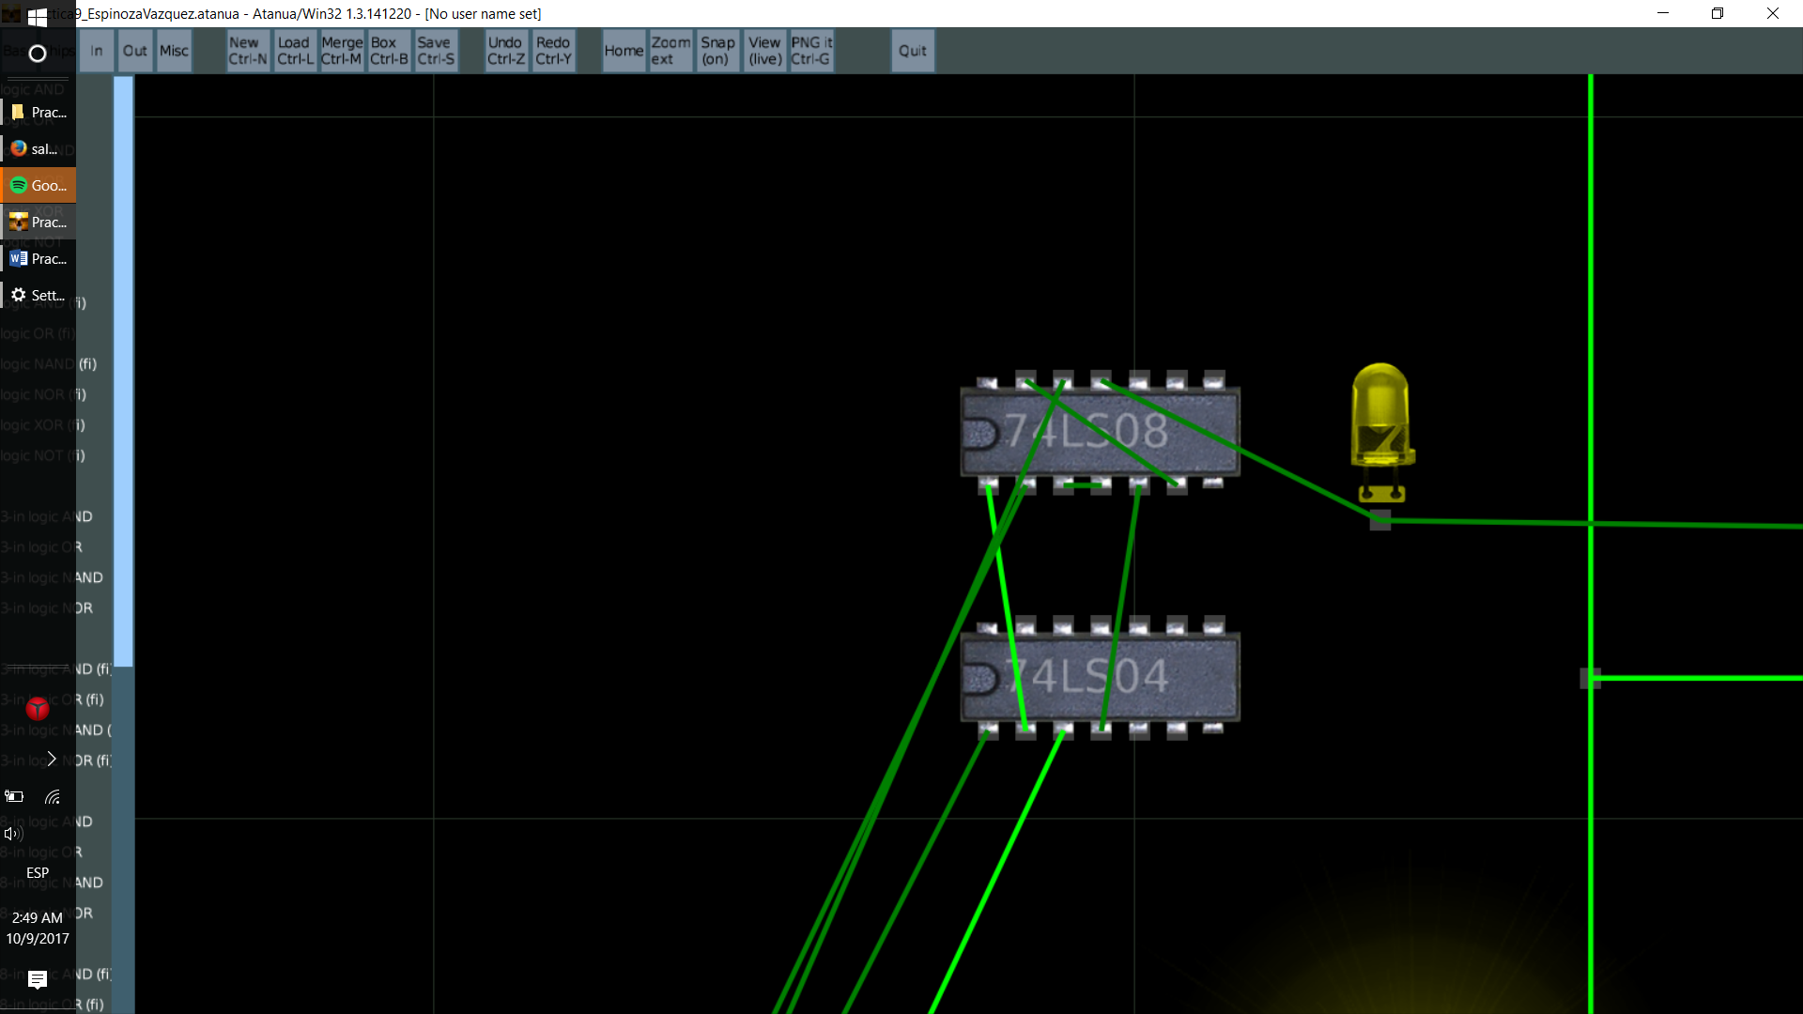

1. A’B’C’D’E’ v A’B’C’D’E v A’B’C’DE’ v A’B’C’DE v A’B’CD’E v A’B’CDE’ v A’BC’D’E’ v A’BC’D’E v A’BC’DE’ v A’BCD’E’ v A’BCDE’ v A’BCDE v AB’C’D’E v AB’C’DE v AB’CD’E v AB’CDE’ v ABC’D’E’ v ABC’D’E v ABC’DE’ v ABCD’E’ v ABCD’E v ABCDE’ v ABCDE

A’B’C’D’ v A’B’C’D v B’CD’E v A’CDE’ v A’BC’D’ v BC’DE’ v BCD’E’ v BCDE v AB’C’E v ACDE’ v ABC’D’ v ABCD’E

A’B’C’ v B’CD’E v CDE’ v BC’D’ v BC’DE’ v BCD’E’ v BCDE v AB’C’E v ABCD’E

C(B’D’E v DE’ v BD’E’ v BDE v ABD’E) v C’(A’B’ v BD’ v BDE’ v AB’E)

1. A’B’C’D’E’ v A’B’C’D’E v A’B’C’DE’ v A’B’C’DE v A’B’CD’E v A’B’CDE’ v A’BC’D’E’ v A’BC’D’E v A’BC’DE’ v A’BCD’E’ v A’BCDE’ v A’BCDE v AB’C’D’E v AB’C’DE v AB’CD’E v AB’CDE’ v ABC’D’E’ v ABC’D’E v ABC’DE’ v ABCD’E’ v ABCD’E v ABCDE’ v ABCDE

A’B’C’D’ v A’B’C’D v B’CD’E v A’CDE’ v A’BC’D’ v BC’DE’ v BCD’E’ v BCDE v AB’C’E v ACDE’ v ABC’D’ v ABCD’E

A’B’C’ v B’CD’E v CDE’ v BC’D’ v BC’DE’ v BCD’E’ v BCDE v AB’C’E v ABCD’E

C(B’D’E v DE’ v BD’E’ v BDE v ABD’E) v C’(A’B’ v BD’ v BDE’ v AB’E)

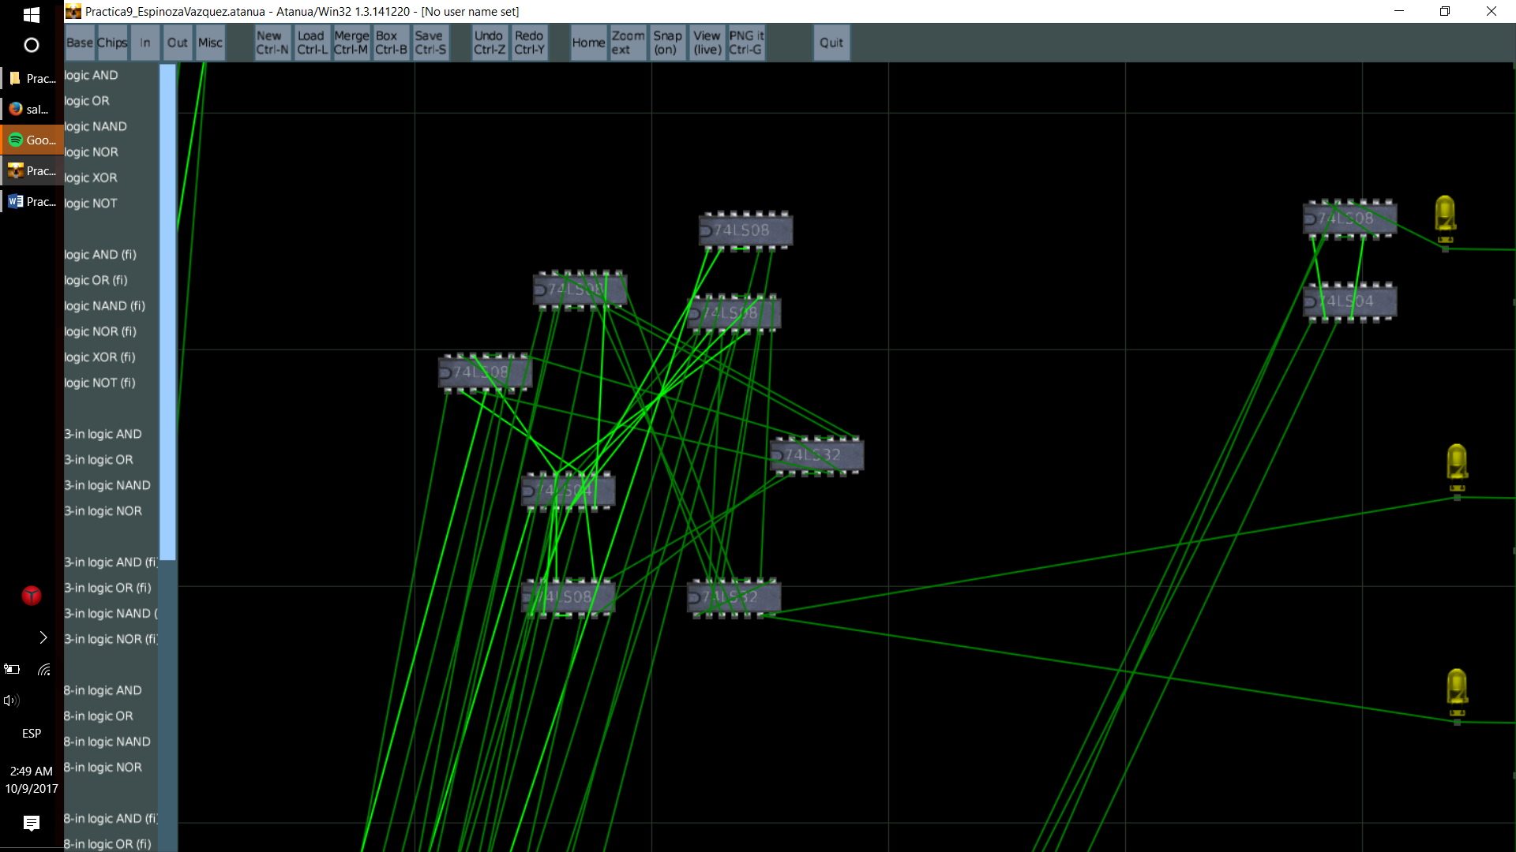

1. AB’C’DE

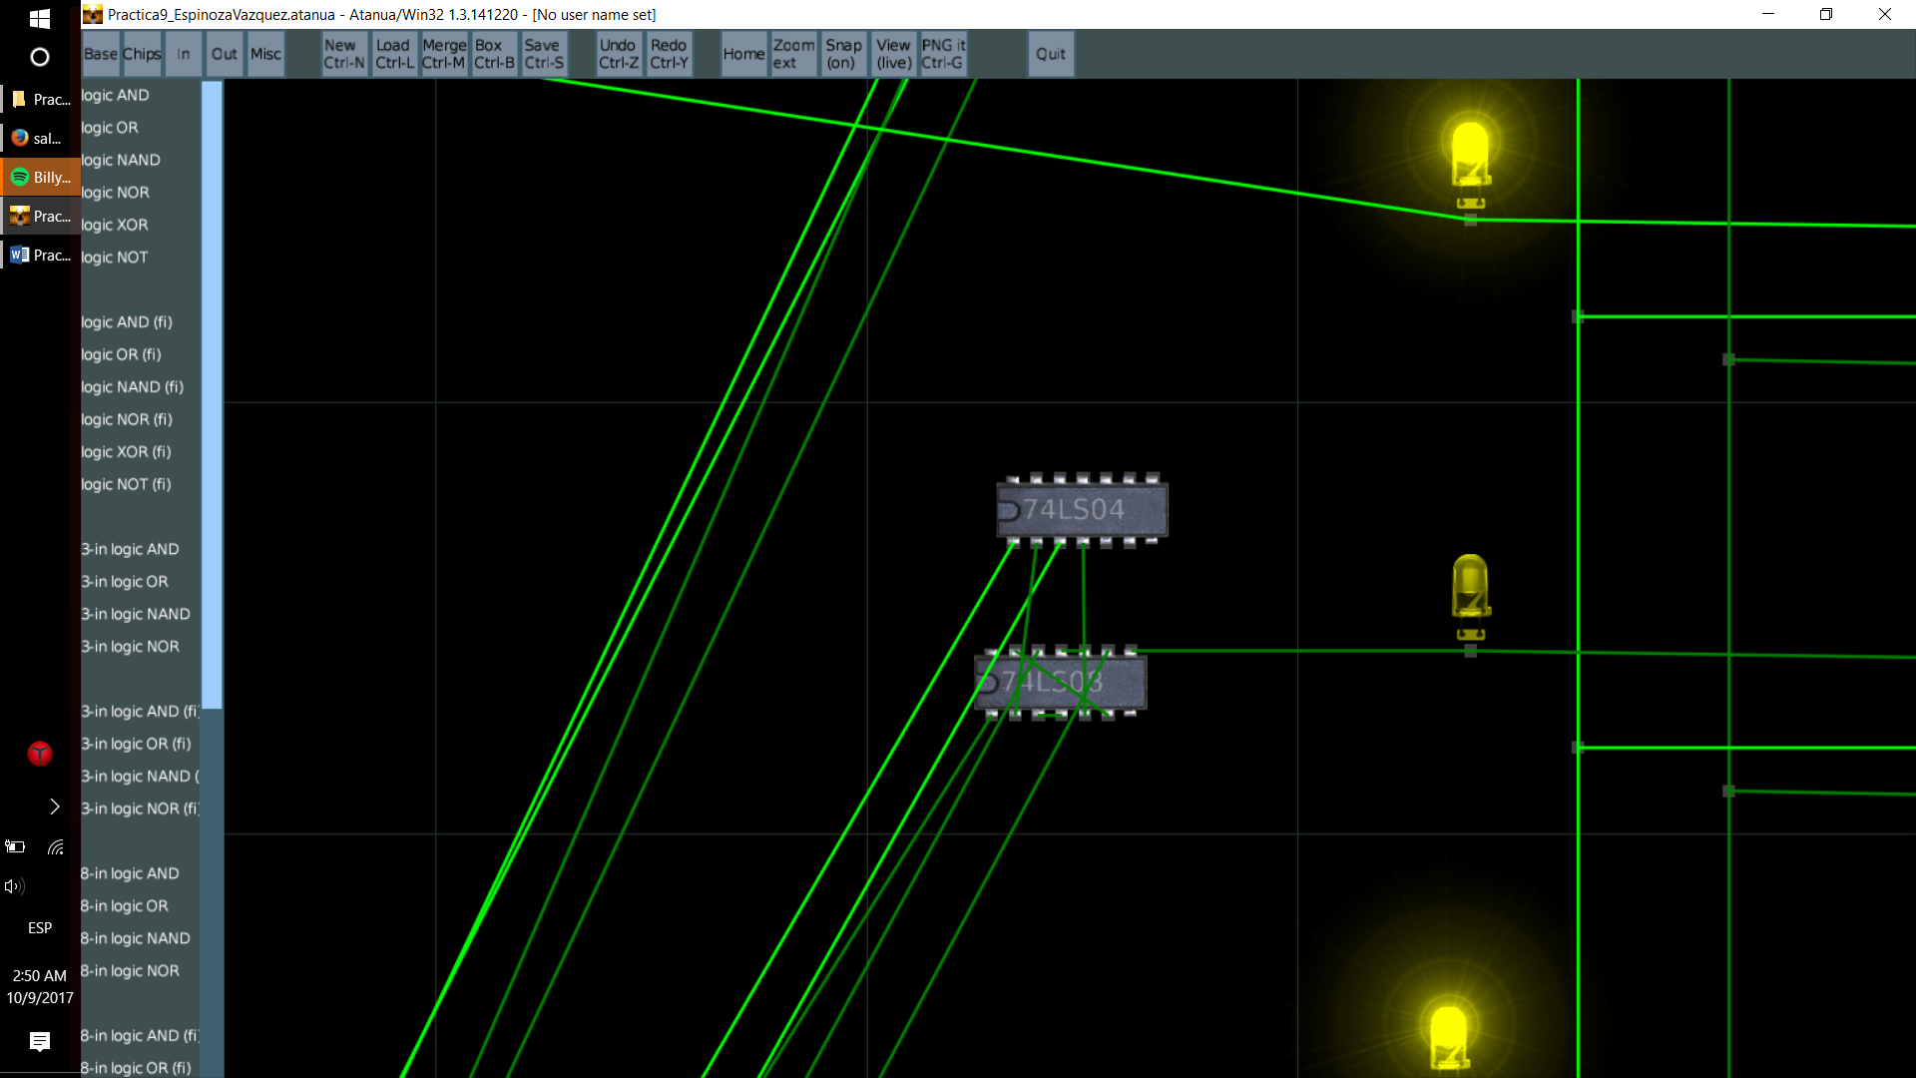

1. A’B’C’DE’ v A’B’CDE’ v A’BC’D’E v A’BCD’E’ v A’BCDE v AB’C’D’E v AB’CDE’ v ABC’D’E v ABCDE’

A’B’DE’ v A’BC’D’E v A’BCD’E’ v A’BCDE v AC’D’E v ACDE’

A’(B’DE’ v BC’D’E v BCD’E’ v BCDE) v A(C’D’E v CDE’)

1. A’B’C’DE’ v A’B’CDE’ v A’BC’D’E v A’BCD’E’ v A’BCDE v AB’C’D’E v AB’CDE’ v ABC’D’E v ABCDE’

A’B’DE’ v A’BC’D’E v A’BCD’E’ v A’BCDE v AC’D’E v ACDE’

A’(B’DE’ v BC’D’E v BCD’E’ v BCDE) v A(C’D’E v CDE’)

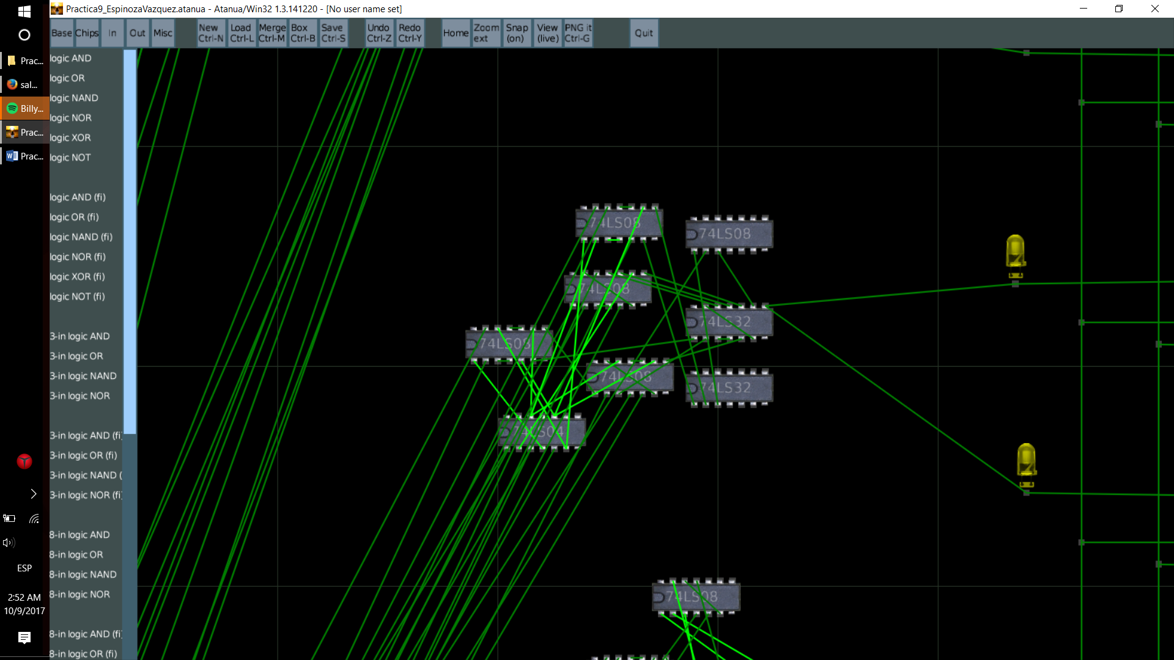

1. _
2. A’B’C’DE v A’B’CD’E v A’BC’DE’ v AB’CD’E v ABC’DE’ v ABCDE

A’B’C’DE v B’CD’E v BC’DE’ v ABCDE

B’(A’C’DE v CD’E) v BD(C’E’ v ACE)

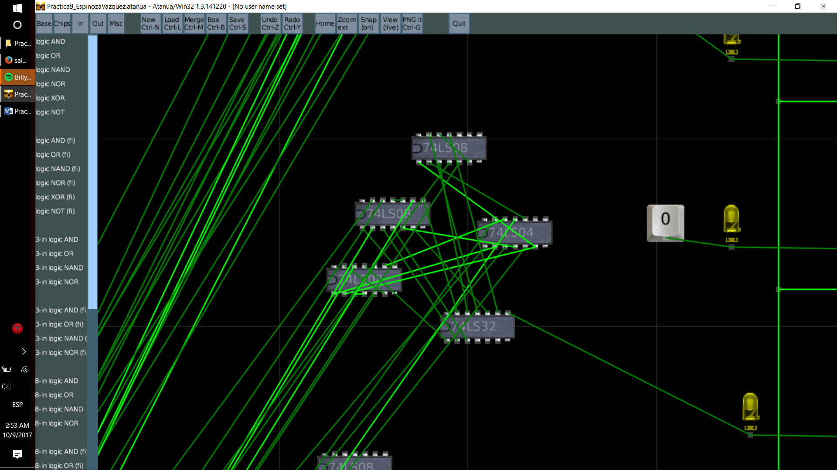

1. A’B’C’D’E’ v A’B’C’D’E v A’B’CD’E’ v A’B’CD’E v A’B’CDE’ v A’BC’D’E v A’BCD’E v AB’C’DE’ v AB’CD’E’ v AB’CD’E v AB’CDE’ v ABC’D’E v ABCD’E’ v ABCD’E

A’B’C’D’ v A’B’CD’ v B’CDE’ v A’BD’E v AB’C’DE’ v AB’CD’ v ABD’E v ABCD’E’

A’B’D’ v B’CDE’ v BD’E v AB’C’DE’ v ABD’E v ABCD’E’

A’B’D’ v BD’E v B’E’(CD v AC’D) v AB(D’E v CD’E’)

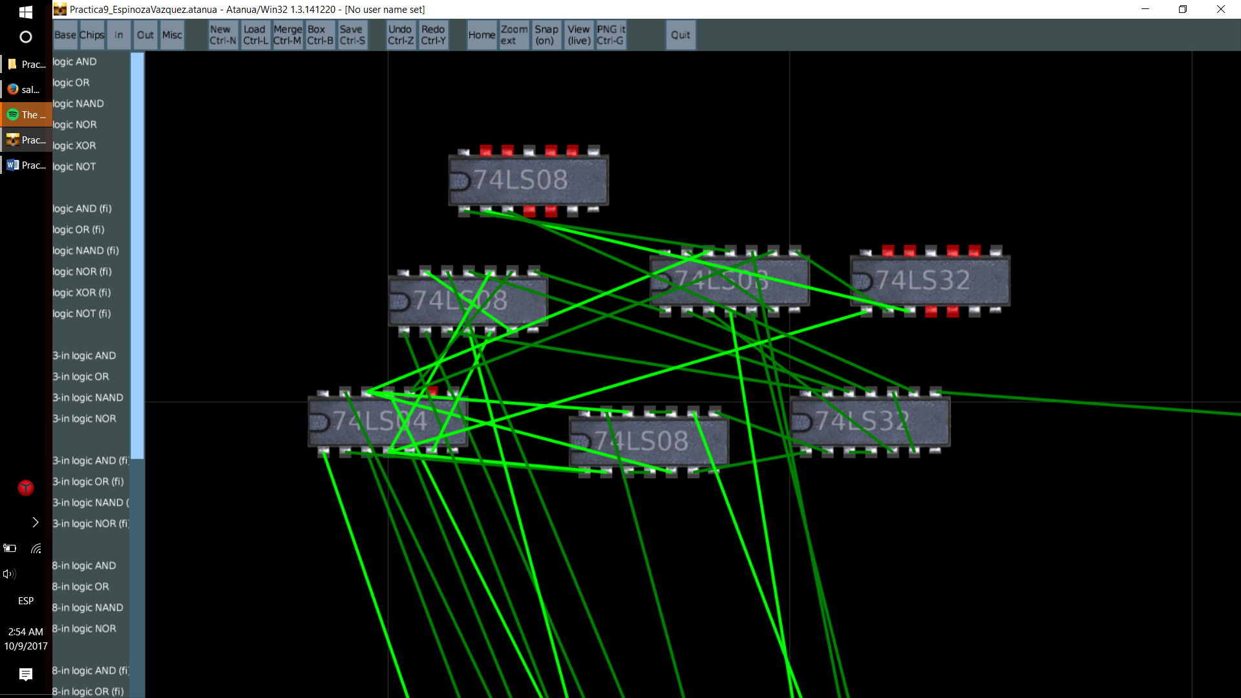

1. A’B’C’D’E’ v A’B’C’D’E v A’B’CDE’ v A’BC’D’E’ v A’BC’DE’ v A’BCDE’ v A’BCDE v AB’CDE’ v ABC’D’E’ v ABC’DE’ v ABCD’E’ v ABCD’E

A’B’C’D’ v A’CDE’ v A’BC’E’ v A’BCDE v AB’CDE’ v ABC’D’E’ v ABC’DE’ v ABCD’

A’B’C’D’ v A’CDE’ v A’BC’E’ v A’BCDE v AB’CDE’ v ABC’E’ v ABCD’

A’B’C’D’ v A’CDE’ v BC’E’ v A’BCDE v AB’CDE’ v ABCD’

A’(B’C’D’ v CDE’ v BCDE) v A(B’CDE’ v BCD’) v BC’E’

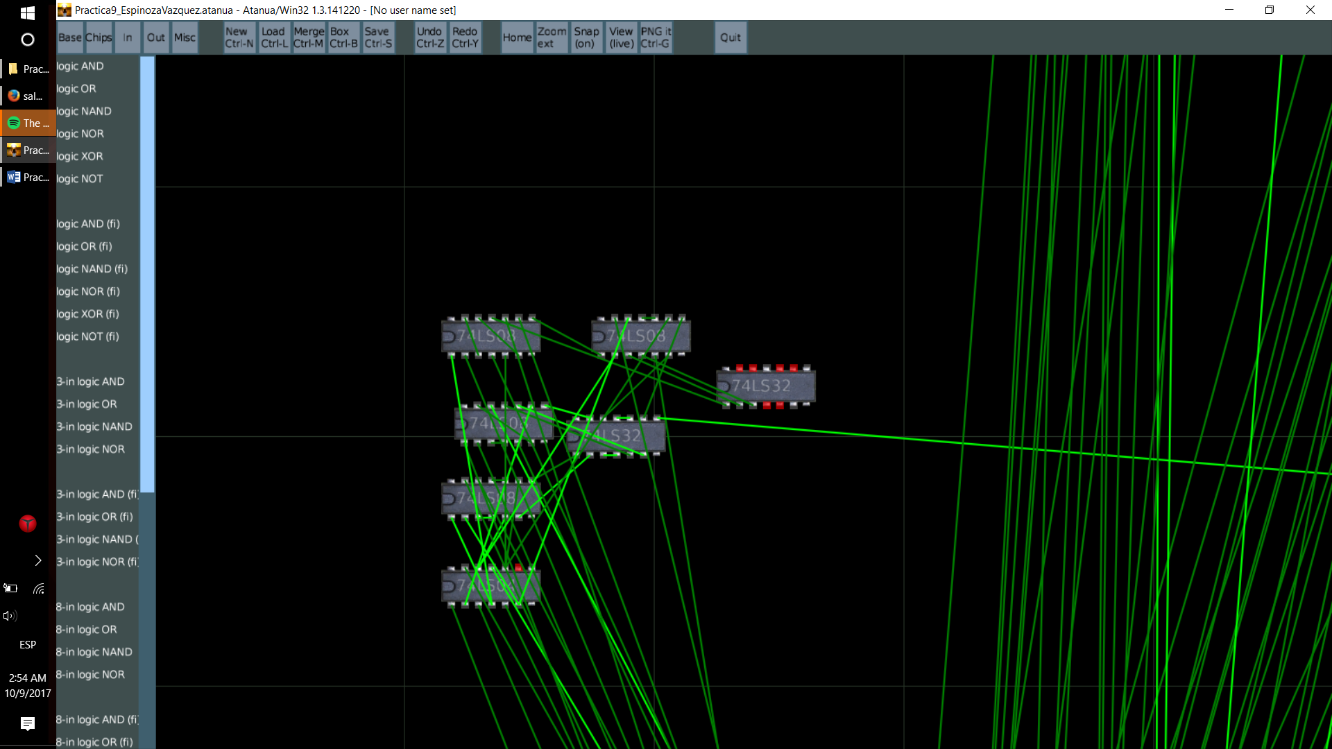

1. A’B’C’D’E’ v A’B’C’D’E v A’B’C’DE v A’BC’D’E’ v A’BC’DE’ v A’BCDE’ v A’BCDE v ABC’D’E’ v ABC’DE’ v ABCD’E’ v ABCD’E v ABCDE

A’B’C’D’ v A’B’C’DE v A’BC’E’ v A’BCD v ABC’E’ v ABCD’ v ABCDE

A’B’C’D’ v A’B’C’DE v BC’E’ v A’BCD v ABCD’ v ABCDE

A’B’C’(D’ v DE) v BC’E’ v BC(A’D v AD’ v ADE)

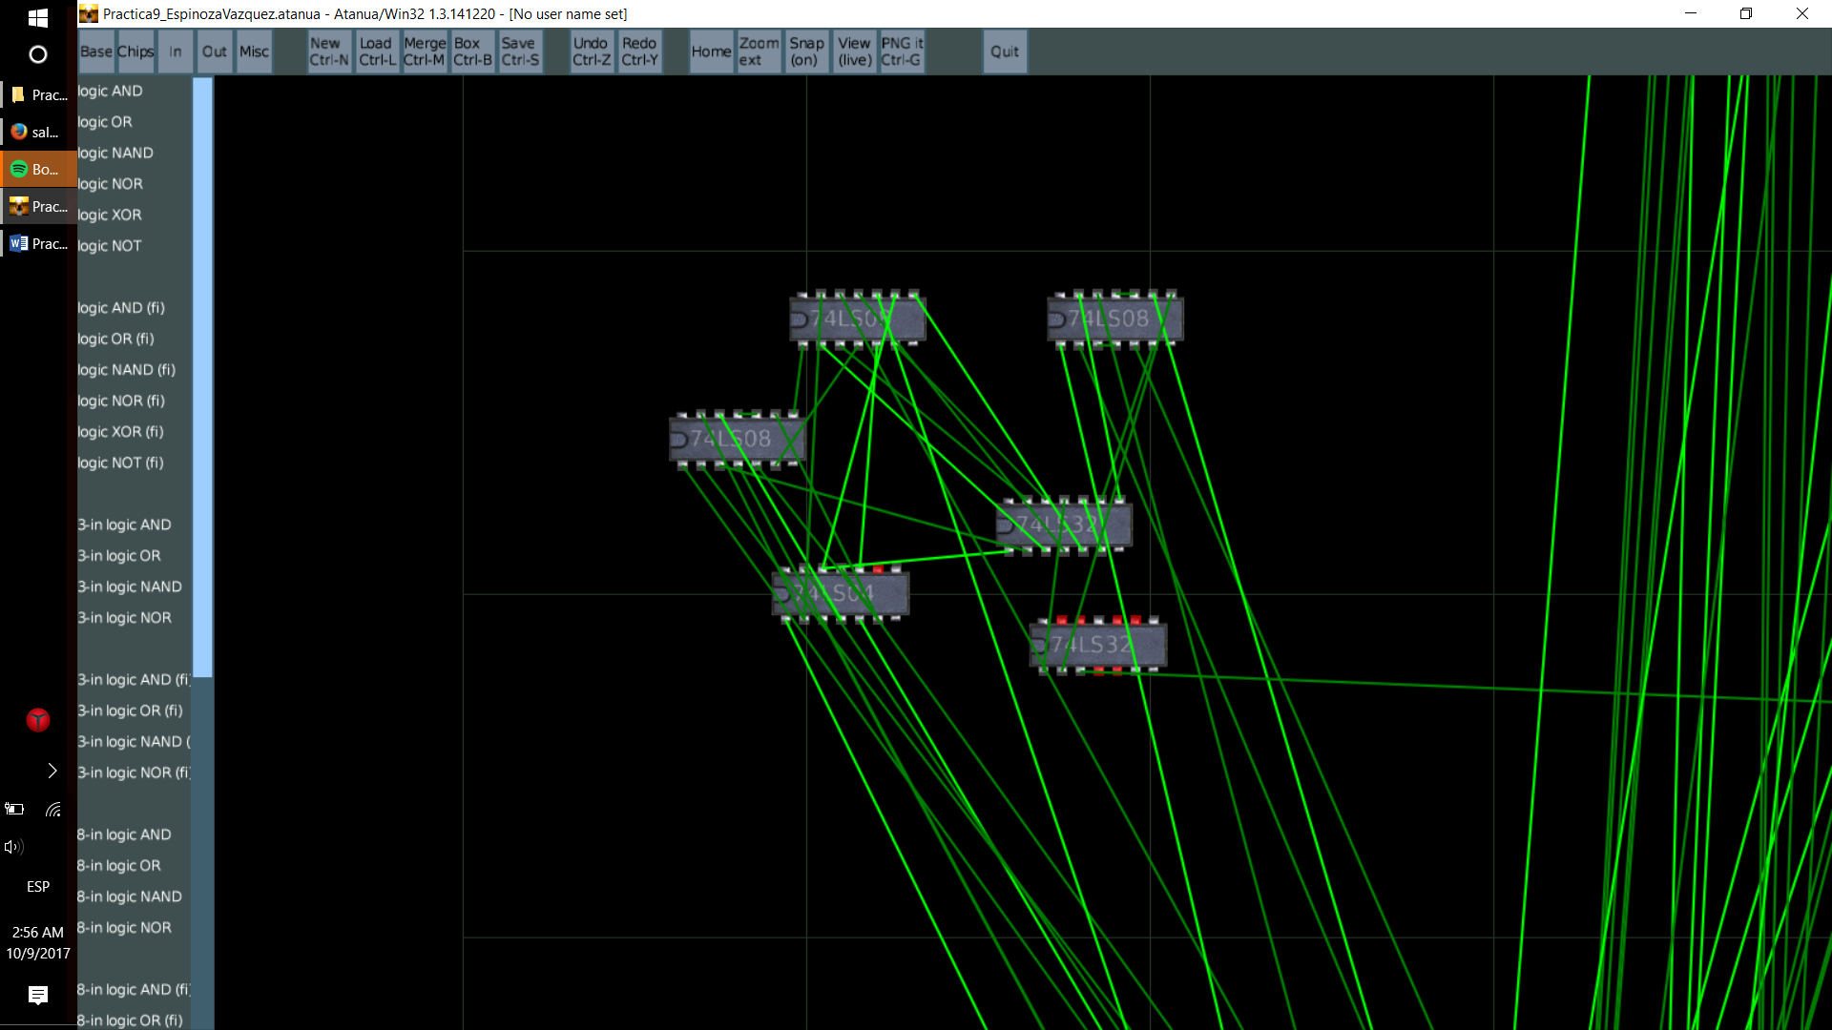

1. A’B’C’D’E’ v A’B’C’D’E v A’B’CD’E’ v A’B’CD’E v A’BC’D’E v A’BC’DE’ v A’BCD’E v AB’C’DE’ v AB’CD’E’ v AB’CD’E v ABC’D’E v ABC’DE’ v ABCD’E’ v ABCD’E

A’B’C’D’ v A’B’CD’ v A’BD’E v BC’DE’ v AB’C’DE’ v AB’CD’ v ABD’E v ABCD’E’

A’B’D’ v BD’E v BC’DE’ v AB’C’DE’ v AB’CD’ v ABCD’E’

A’B’D’ v B(D’E v C’DE’ v ACD’E’) v AB’(C’DE’ v CD’)

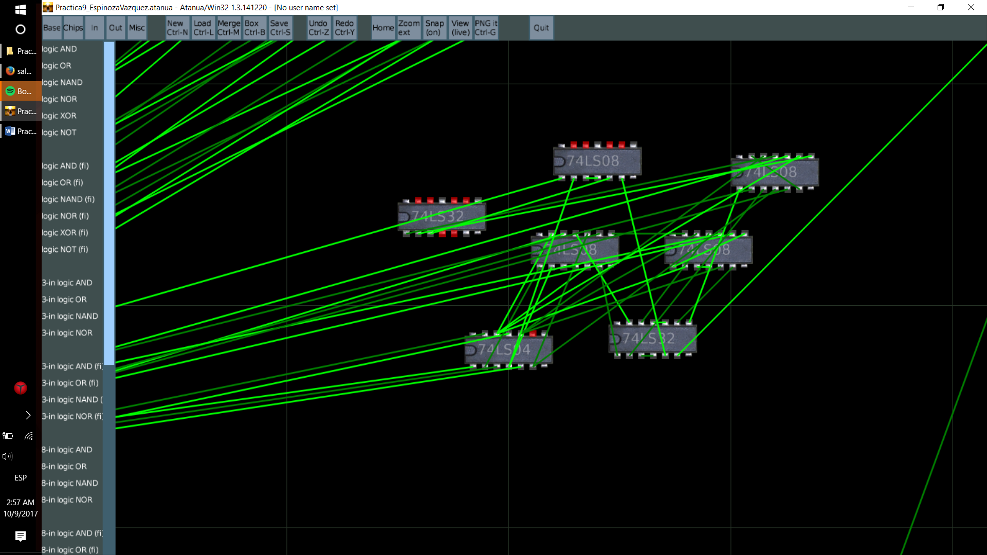

1. A’B’C’DE v AB’C’DE v ABCDE

B’C’DE v ABCDE

